 

­

**Web Application Development**

Team 4

MEMBERS:

* Pardo Rómulo
* Pila Nataly
* Pilligua Washington
* Romero Cristhian

Theme:

Client - Server Web Development

**Activity 3**

Tutor:

PhD. JORGE EDISON LASCANO Mgs

**ACTIVITY #3**

Home page mockups called index.

***Figure 1.***

*Home page mockup interface (index).*

Note. Own elaboration by team 4 in Lucidchart

Link: <https://lucid.app/lucidchart/4025285a-2ca2-4205-9fea-042b0c55fdab/view?page=0_0>

***Figure 2.***

*Home page interface (index).*

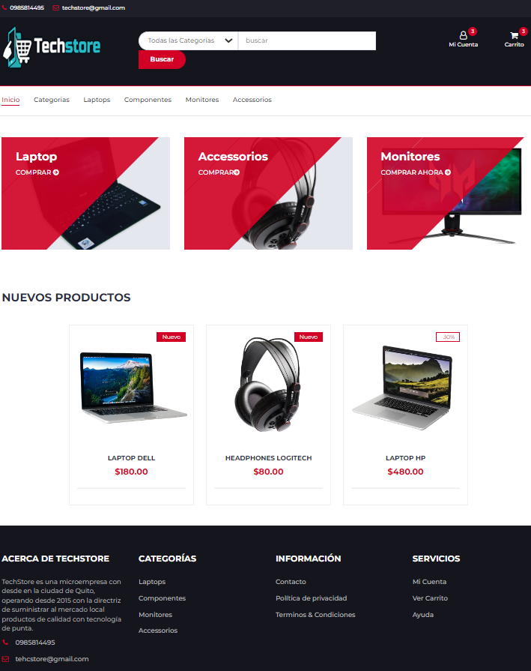

Note. Own elaboration by team 4 in Lucidchart

***Figure 3.***

*Home page mockup interface (login).*

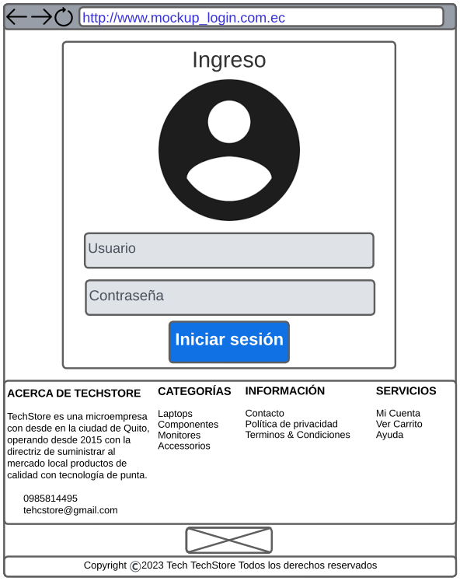

Note. Own elaboration by team 4 in Lucidchart

Link: <https://lucid.app/lucidchart/a1f94078-fb4e-470f-ab04-1b1695e79f0f/view?page=0_0>

***Figure 4.***

*Home page mockup interface (register).*

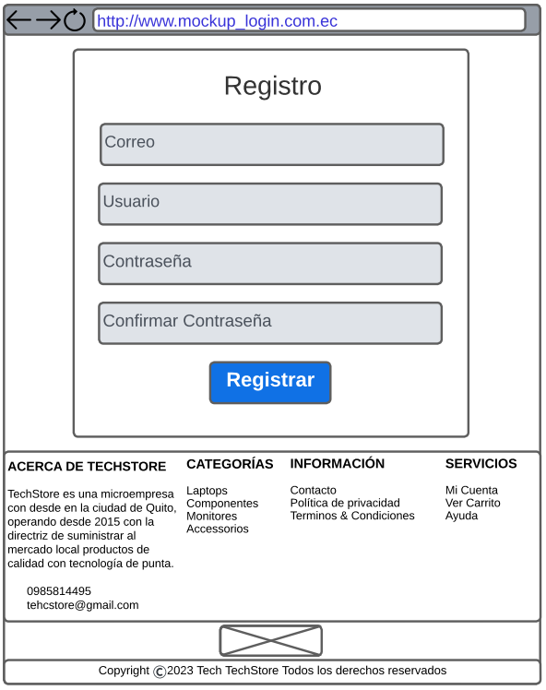

Note. Own elaboration by team 4 in Lucidchart

Link: <https://lucid.app/lucidchart/2d14c092-d166-4388-a7da-1e9300f0bf79/view?page=0_0>

***Figure 5.***

*Home page mockup interface (register product).*

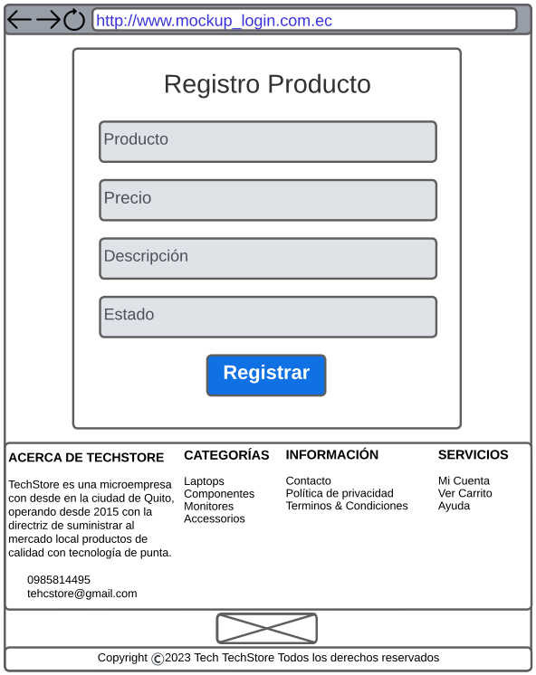

Note. Own elaboration by team 4 in Lucidchart

Link: <https://lucid.app/lucidchart/19c6cd8b-ea7a-4d89-ae46-c340f3ee04f6/view?page=0_0#>

***Figure 6.***

*Home page mockup interface (clients).*

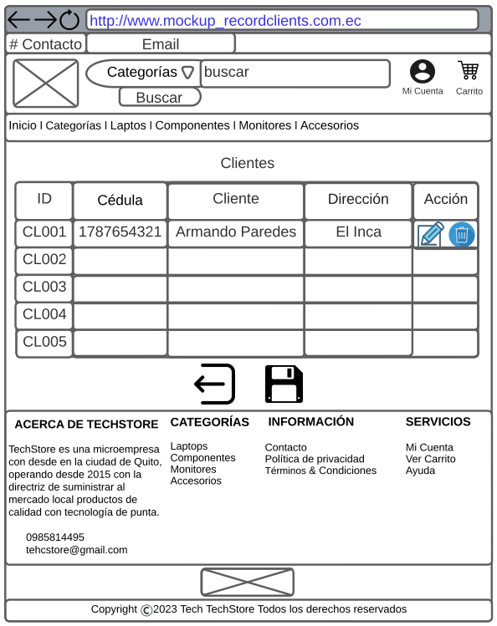

Note. Own elaboration by team 4 in Lucidchart

Link: [https://lucid.app/lucidchart/2922aac0-6423-4e74-9138-31538453a2ad/view?page=0_0#](https://lucid.app/lucidchart/2922aac0-6423-4e74-9138-31538453a2ad/view?page=0_0)

***Figure 7.***

*Home page mockup interface (register client).*

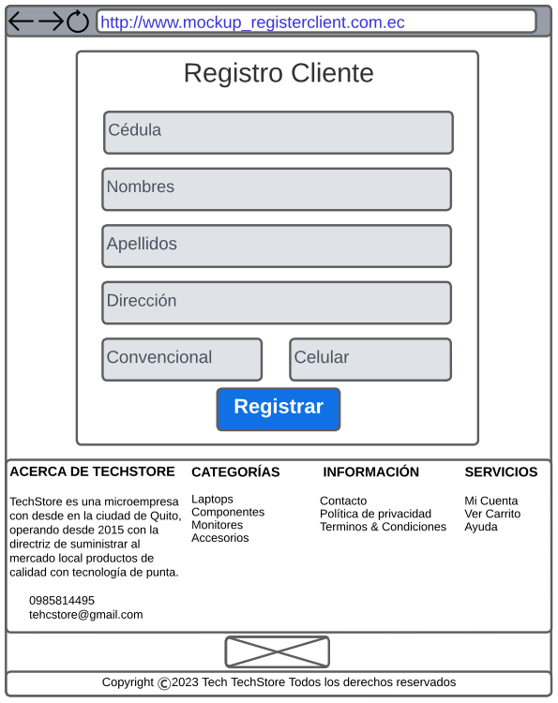

Note. Own elaboration by team 4 in Lucidchart

Link: [https://lucid.app/lucidchart/debf2fe8-bcd1-4dcc-9baf-10b35357cc3b/view?page=0_0#](https://lucid.app/lucidchart/debf2fe8-bcd1-4dcc-9baf-10b35357cc3b/view?page=0_0)

***Figure 8.***

*Home page mockup interface (register vendor).*

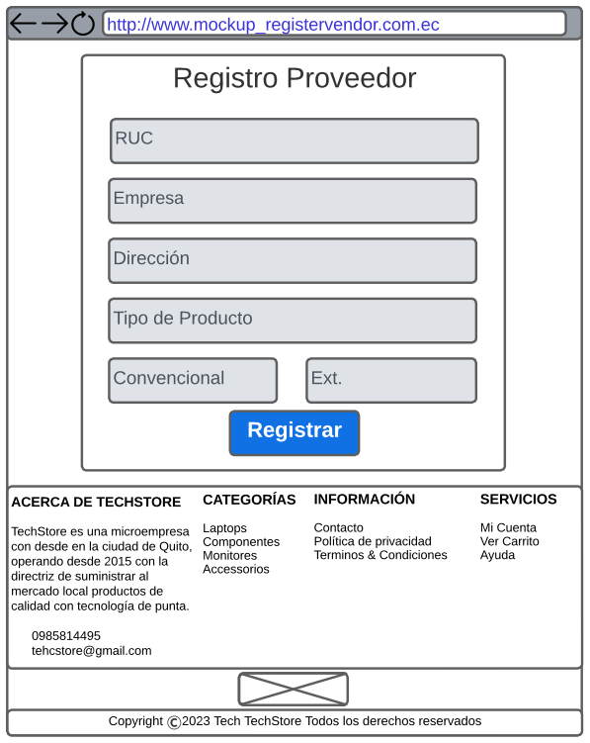

Note. Own elaboration by team 4 in Lucidchart

Link: [https://lucid.app/lucidchart/1355b956-b3b9-4c2d-bb66-fc65d9be2b2e/view?page=0_0#](https://lucid.app/lucidchart/1355b956-b3b9-4c2d-bb66-fc65d9be2b2e/view?page=0_0)

***Figure 9.***

*Home page mockup interface (register employee).*

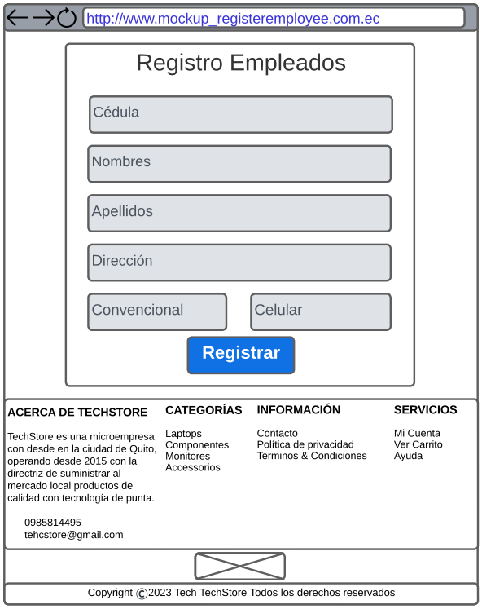

Note. Own elaboration by team 4 in Lucidchart

Link: <https://lucid.app/lucidchart/19a4d75e-dd76-4927-ba95-6eb009a22b9f/view?page=0_0#>